INTELLIGENT ADMISSION:

THE FUTURE OF UNIVERSITY DECISION

MAKING WITH MACHING LEARNING

**TEAM ID:** NM2023TMID15973

**TEAM LEADER**

**E.TRISHA:** B61F3BC914733FEAB8F4B74F82E968C5

**TEAM MEMBERS:**

**M.PARAMESWARI**

**J.RUBIKA**

**R.KOWSALYA**

smartinternz.png

|  |  |
| --- | --- |
| SI NO | **TITLE** |
| 1. | **INTRODUCTION** |
|  | 1.1 PROJECT OVERVIEW |
|  | 1.2 PURPOSE OF PROJECT |
| 2. | **PROBLEM DEFINITION AND DESIGN THINKING** |
|  | 2.1 EMPATHY MAP |
|  | 2.2 IDEATION AND BRAIN STORMING |
| 3. | **RESULTS** |
| 4. | **ADVANTAGES AND DISADVANTAGES** |
| 5. | **APPLICATIONS** |
| 6. | **CONCLUSION** |
| 7. | **FUTURE SCOPE** |
| 8. | **APPENDIX** |
|  | 1. Source code |

smartinternz.png

**1.INTRODUCTION**

Intelligent admission with machine learning refers to the use of advanced algorithms and computational techniques to automate and optimize the admission process for educational institutions. Machine learning algorithms can analyze large amounts of data, such as academic records, test scores, extracurricular activities, and personal statements, to identify patterns and make predictions about which students are most likely to succeed in a given program.

The use of machine learning in the admission process can help to reduce biases and subjectivity that may be present in traditional methods. By analyzing data objectively, machine learning algorithms can provide a more accurate and fair assessment of each applicant's potential. This can also help to improve the efficiency of the admission process, allowing institutions to evaluate a larger number of applicants in a shorter period of time.

Intelligent admission systems can also help institutions to identify and attract the most promising candidates, based on their profiles and academic backgrounds. By providing personalized recommendations and targeted outreach, these systems can help to ensure that institutions are able to recruit a diverse and talented student body that can contribute to the academic community.

Overall, the use of machine learning in the admission process has the potential to transform the way that institutions evaluate and select candidates. By leveraging the power of data and analytics, these systems can help to create a more efficient, objective, and inclusive admission process that benefits both institutions and students alike.

smartinternz.png

* 1. **OVERVIEW**

Intelligent admission with machine learning refers to the use of machine learning algorithms to aid in the admission process of a university or college. This process involves predicting the probability of a student's success in academics based on their application and other relevant data.

The use of machine learning algorithms can help automate the admission process, saving time and resources for universities and colleges. It can also reduce human biases and errors that may occur during the manual screening of applications.

Some of the key features that can be used in intelligent admission include the student's academic history, test scores, extracurricular activities, essays, and letters of recommendation. Machine learning algorithms can analyze these features to predict the likelihood of a student's success in academics and their fit for the university or college.

Overall, the goal of intelligent admission is to increase the efficiency and effectiveness of the admission process while ensuring that the best-suited students are admitted to the university or college.

* 1. **PURPOSE**

The purpose of intelligent admission with machine learning is to streamline and improve the admission process of universities and colleges. Here are some of the main reasons for using machine learning algorithms in the admission process:

**1. Efficiency:** The use of machine learning algorithms can automate the screening process, saving time and resources for universities and colleges. This can help to process a large number of applications more quickly, resulting in faster admissions decisions.

smartinternz.png

**2. Objectivity:** Machine learning algorithms can help reduce human biases and errors that may occur during the manual screening of applications. By analyzing data objectively, algorithms can provide a fair assessment of each applicant's qualifications and potential.

**3. Accuracy:** Machine learning algorithms can analyze a wide range of data points to make more accurate predictions about a student's success in academics. This can help to identify the best-suited students for the university or college, leading to better retention rates and higher graduation rates.

**4. Personalization**: Machine learning algorithms can also personalize the admission process for each applicant. By analyzing data such as academic history, extracurricular activities, and essays, algorithms can provide more tailored feedback and guidance to each applicant.

Overall, the purpose of intelligent admission with machine learning is to create a more efficient, objective, and accurate admission process that benefits both universities and colleges and applicants.

**2. PROBLEM DEFINITION AND DESIGN THINKING**

**PROBLEM DEFINITION:**

The problem definition of intelligent admission with machine learning is to develop an algorithm that can accurately predict the success of a student in academics based on various factors such as academic history, test scores, extracurricular activities, essays, and letters of recommendation. The algorithm should be able to analyze these factors and provide a prediction of the likelihood of the student's success, which can help universities and colleges make better-informed admission decisions.

smartinternz.png

However, there are several challenges that must be addressed in developing an intelligent admission system with machine learning. Some of these challenges include:

**1. Data quality:** The accuracy and completeness of the data used in the machine learning algorithm can significantly impact the accuracy of the predictions. Ensuring that the data is clean, relevant, and reliable can be a challenge.

**2. Bias:** Machine learning algorithms can be prone to bias, which can lead to unfair or discriminatory decisions. It is important to develop algorithms that are fair and unbiased, and that do not discriminate based on factors such as race, gender, or socioeconomic status.

**3. Transparency:** It is essential to ensure that the algorithm is transparent and understandable, so that applicants and other stakeholders can understand how the admission decisions are made.

**4. Privacy:** The use of sensitive data such as academic records and personal information can raise privacy concerns. It is important to ensure that the data is stored securely and that the algorithm is compliant with data privacy laws.

Overall, the problem definition of intelligent admission with machine learning is to develop a system that is accurate, fair, transparent, and respects privacy, while also improving the efficiency and effectiveness of the admission process.

smartinternz.png

**DESIGN THINKING:**

Design thinking is a problem-solving methodology that involves understanding the needs and perspectives of users to create innovative solutions that meet their needs. Applying design thinking to the development of intelligent admission with machine learning involves the following steps:

**1. Empathize:** The first step is to understand the needs and perspectives of the stakeholders involved in the admission process, including university staff, applicants, and parents. This can involve conducting interviews, surveys, and observation to gain insights into their needs and pain points.

**2. Define:** Based on the insights gathered from the empathize stage, the next step is to define the problem and the goals of the intelligent admission system. This can involve creating a problem statement that clarifies the specific issues that the system aims to address and the outcomes it seeks to achieve.

**3. Ideate:** In this stage, a range of ideas and solutions are generated to address the problem statement. This can involve brainstorming sessions with stakeholders and considering various technologies and approaches that can be used.

**4. Prototype:** After generating a range of ideas, the next step is to create prototypes of the most promising solutions. This can involve creating mockups or simple versions of the system to test and refine the ideas.

**5. Test:** Finally, the prototypes are tested and evaluated to determine whether they meet the needs of the stakeholders and achieve the goals of the system. This can involve gathering feedback from stakeholders, analyzing data, and making changes based on the feedback received.

Applying design thinking to the development of intelligent admission with machine learning can help to ensure that the system is user-centered, innovative, and effective in meeting the needs of all stakeholders involved.

smartinternz.png

**2.1 EMPATHY MAP**

An empathy map is a collaborative visualization used to articulate what we know about a particular type of user. It externalizes knowledge about users in order to 1) create a shared understanding of user needs, and 2) aid in decision making.

This article is a guide to empathy mapping and its users.

An empathy map is a collaborative visualization used to articulate what we know about a

particular type of user. It externalizes knowledge about users in order to 1) create a shared

understanding of user needs, and 2) aid in decision making

An empathy map is a collaborative visualization used to articulate what we know about a

particular type of user. It externalizes knowledge about users in order to 1) create a shared

understanding of user needs, and 2) aid in decision making

An empathy map is a collaborative visualization used to articulate what we know about a

particular type of user. It externalizes knowledge about users in order to 1) create a shared

understanding of user needs, and 2) aid in decision making

An empathy map is a collaborative visualization used to articulate what we know about a

particular type of user. It externalizes knowledge about users in order to 1) create a shared

understanding of user needs, and 2) aid in decision making

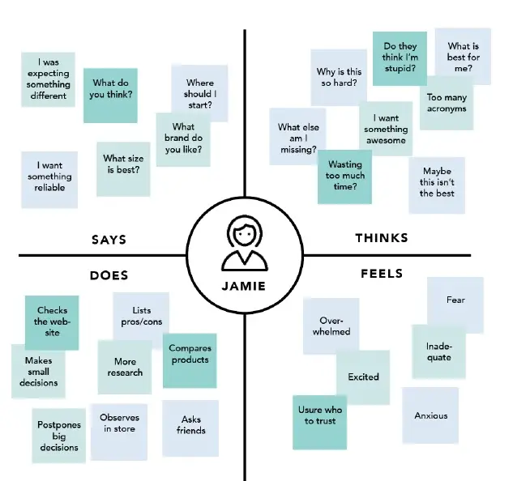

smartinternz.png

**1. Define scope and goals:**

a. What user or persona will you map? Will you map a persona or an individual user? Always start with a 1:1 mapping (1 user/persona per empathy map). This means that, if you have multiple personas, there should be an empathy map for each.

b. Define your primary purpose for empathy mapping. Is it to align the team on your user? If so, be sure everyone is present during the empathy-mapping activity. Is it to analyze an interview transcript? If so, set a clear scope and timebox your effort to ensure you have time to map multiple user interviews.

**2. Gather materials:**

Your purpose should dictate the medium you use to create an empathy map. If you will be working with an entire team, have a large whiteboard, sticky notes, and markers readily available. (The outcome will look somewhat like the illustration above.) If empathy mapping alone, create a system that works for you. The easier to share out with the rest of the team, the better.

**3. Collect research:**

Gather the research you will be using to fuel your empathy map. Empathy mapping is a qualitative method, so you will need qualitative inputs: user interviews, field studies, diary studies, listening sessions, or qualitative surveys.

**4. Individually generate sticky notes for each quadrant:**

Once you have research inputs, you can proceed to mapping as a team. In the beginning, everybody should read through the research individually. As each team member digests the data, they can fill out sticky notes that align to the four quadrants. Next, team members can add their notes to the map on the whiteboard.

smartinternz.png

**5. Converge to cluster and synthesize:**

In this step, the team moves through the stickies on the board collaboratively and clusters similar notes that belong to the same quadrant. Name your clusters with themes that represent each group (for example, “validation from others” or “research”). Repeat themes in each quadrant if necessary. The activity of clustering facilitates discussion and alignment — the goal being to arrive at a shared understanding of your user by all team members.

Once your empathy map is clustered, you can begin to vocalize and align as a team on your findings. What outliers (or data points that did not fit in any cluster) are there? What themes were repeated in all the quadrants? What themes only exist in one quadrant? What gaps exist in our understanding?

**6. Polish and plan:**

If you feel that you need more detail or you have unique needs, adapt the map by including additional quadrants (like Goals the example below) or by increasing specificity to existing quadrants. Depending on the purpose of your empathy map, polish and digitize the output accordingly. Be sure to include the user, any outstanding questions, the data and version number. Plan to circle back to the empathy map as more research is gathered or to guide UX decision.

smartinternz.png

**2.2 IDEATION AND BRAIN STORMING**

**smartinternz.png**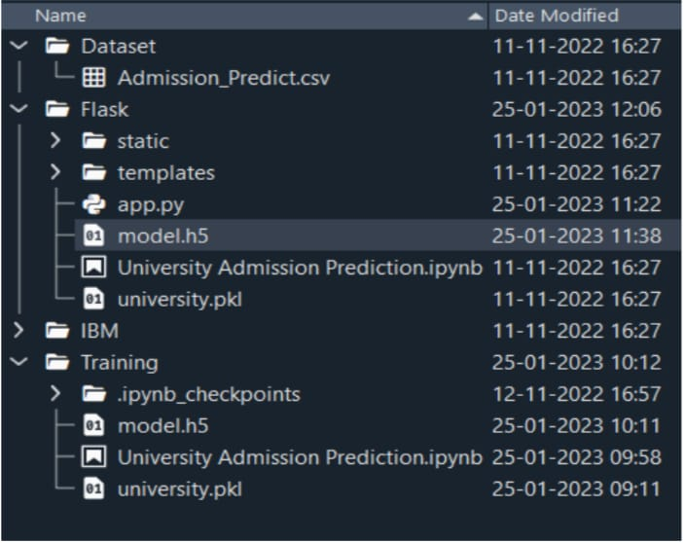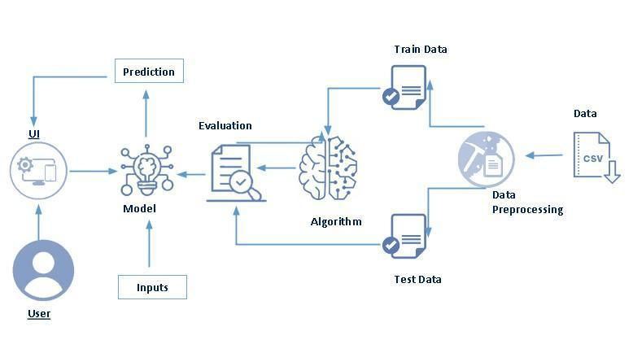

1.Define scope and goals:

a. What user or persona will you map? Will you map a persona or an individual user?

Always start with a 1:1 mapping (1 user/persona per empathy map). This means that, if you have

multiple personas, there should be an empathy map for each.

b. Define your primary purpose for empathy mapping. Is it to align the team on your user?

If so, be sure everyone is present during the empathy-mapping activity. Is it to analyze an interview

transcript? If so, set a clear scope and timebox your effort to ensure you have time to map multiple

user interviews. **3.RESULT**

**3.RESULTS**

**smartinternz.png** Through this educational model, the students can guide their own learning. They can have their own pace and make decision about what to learn and how to learn. They can choose the subjects they are interested in, the teacher they want to learn from and what curriculum, standards and pattern they want to follow. 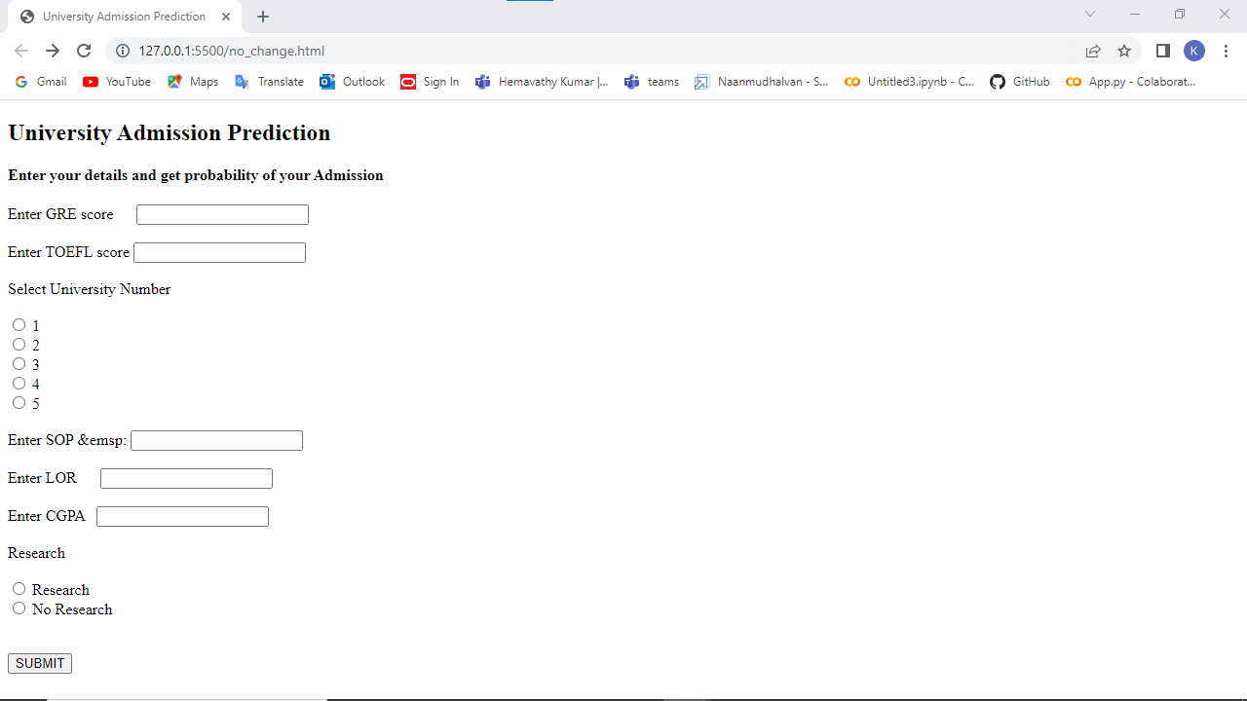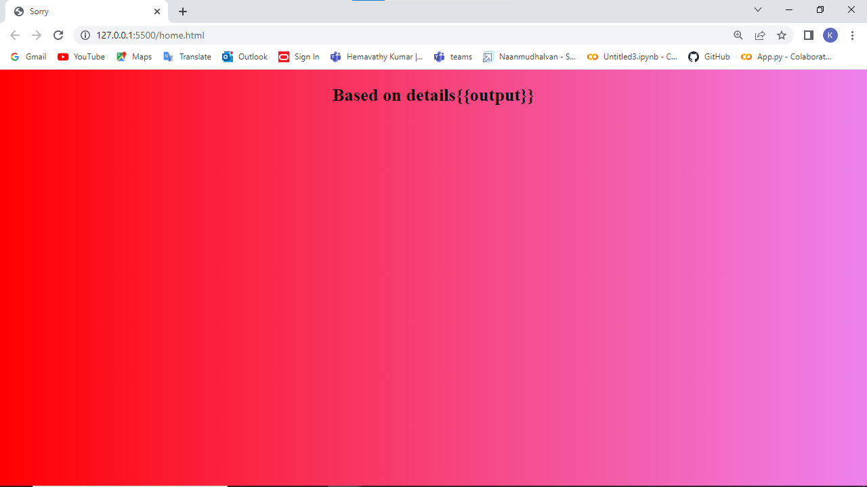

**4. ADVANTAGES AND DISADVANTAGES**

**ADVANTAGES:**

* **Improved Efficiency:** Machine learning algorithms can process large amounts of data quickly and accurately, which can help to streamline the admission process and reduce the workload of university staff.
* **Data-Driven Decision Making:** By analyzing various data points such as academic records, test scores, and essays, machine learning algorithms can provide more accurate predictions of student success, which can help universities make better-informed admission decisions.
* **Improved Diversity and Inclusivity:** Machine learning algorithms can be designed to reduce bias and promote diversity and inclusivity in the admission process. By focusing on objective criteria, rather than subjective factors such as race or gender, machine learning algorithms can help to level the playing field for all applicants.
* **Personalized Feedback:** By analyzing the strengths and weaknesses of each applicant, machine learning algorithms can provide personalized feedback that can help applicants improve their applications and increase their chances of being admitted.

**smartinternz.png**

**DISADVANTAGES:**

* **Data Quality:** The accuracy and completeness of the data used in machine learning algorithms can impact the accuracy of the predictions. If the data is incomplete or biased, the algorithm may provide inaccurate predictions.
* **Privacy Concerns:** The use of sensitive data such as academic records and personal information can raise privacy concerns. It is important to ensure that the data is stored securely and that the algorithm is compliant with data privacy laws.
* **Lack of Human Judgment**: Machine learning algorithms rely on data and mathematical models to make predictions, which may lack the human judgment and intuition that can be important in the admission process.
* **Difficulty in Interpreting Results:** Machine learning algorithms can be complex and difficult to interpret, which can make it challenging for stakeholders to understand how admission decisions are made. It is important to ensure that the algorithms are transparent and understandable.

**5.APPLICATION**

The application of intelligent admission with machine learning involves the use of machine learning algorithms to analyze large amounts of data and make informed admission decisions. Here are some examples of how intelligent admission with machine learning can be applied:

**smartinternz.png1. Predictive Analytics**: Machine learning algorithms can be used to analyze data such as test scores, academic records, and extracurricular activities to predict the likelihood of student success. This can help universities make informed admission decisions and allocate resources more effectively.

**2. Personalized Feedback:** Machine learning algorithms can be used to analyze essays and other application materials and provide personalized feedback to applicants. This can help applicants understand their strengths and weaknesses and improve their applications.

**3. Bias Reduction:** Machine learning algorithms can be designed to reduce bias in the admission process by focusing on objective criteria such as academic records and test scores, rather than subjective factors such as race or gender.

**4. Resource Allocation**: Machine learning algorithms can be used to predict enrollment rates and allocate resources such as financial aid and housing more effectively.

**5. Fraud Detection:** Machine learning algorithms can be used to detect fraudulent applications by analyzing patterns in the data and identifying outliers.

**smartinternz.png6.CONCULSION**

Intelligent admission with machine learning has the potential to revolutionize the admission process for universities. By leveraging the power of machine learning algorithms, universities can analyze large amounts of data and make more informed admission decisions. This can result in more efficient processes, improved diversity and inclusivity, and a better overall experience for applicants However, there are also challenges and potential drawbacks to consider, such as data quality issues, privacy concerns, and the lack of human judgment in the process. It is important for universities to address these challenges and ensure that the algorithms are transparent and understandable Overall, intelligent admission with machine learning is a promising approach that has the potential to transform the admission process and help universities make more informed decisions. By leveraging the power of data and machine learning, universities can ensure that the most qualified and deserving applicants are admitted, while also promoting diversity and inclusivity in the process.

**7.FEATURE SCOPE :**

The future scope of intelligent admission with machine learning is vast and promising. Here are some potential areas of growth and development in the field:

**1. More Sophisticated Algorithms:** Machine learning algorithms are constantly evolving and improving. In the future, we can expect to see more sophisticated algorithms that can analyze even more data and provide even more accurate predictions.

**2. Enhanced Personalization:** As machine learning algorithms become more advanced, they will be able to provide even more personalized feedback and guidance to applicants, helping them to improve their applications and increase their chances of being admitted.

**3. Integration with other Technologies:** Machine learning algorithms can be integrated with other technologies such as virtual reality and chatbots to create a more interactive and engaging applicant experience.

**4. Improved Diversity and Inclusivity:** As machine learning algorithms become more sophisticated and accurate, they can be designed to reduce bias and promote diversity and inclusivity in the admission process.

**5. Enhanced Security and Privacy:** With the growing concern over data security and privacy, we can expect to see more robust security measures and better data protection mechanisms in place.

Overall, the future of intelligent admission with machine learning is bright, and we can expect to see continued growth and development in the field as universities strive to improve their admission processes and provide a better experience for applicants.

smartinternz.png

**8.APPENDIX**

**A)SOURCE CODE**

**app.py**

from flask import Flask, request, render_template, jsonify

from tensorflow import keras

import joblib

import numpy as np

from sklearn.preprocessing import MinMaxScaler

sc = MinMaxScaler()

from sklearn.preprocessing import MinMaxScaler

import pandas as pd

app = Flask(__name__)

# Import necessary libraries

# model = pickle.load(open('university.pkl', 'rb))

# load model trained model

# Load your trained model

model = keras.models.load_model('C:/Users/ELCOT/PycharmProjects/pythonProject/flask/model.h5')

scaler=joblib.load('C:/Users/ELCOT/PycharmProjects/pythonProject/flask/scaler.pkl')

@app.route('/')

def entry():

return render_template('home.html')

@app.route('/getdata', methods=['post'])

def home():

gre = request.form['gre']

toefl = request.form['toefl']

uni_no = request.form['uni_num']

sop = request.form['sop']

lor = request.form['lor']

cgpa = request.form['cgpa']

research = request.form['Research']

variables = [[int(gre), int(toefl), int(uni_no), float(sop), float(lor), float(cgpa), int(research)]]

# Define new input data

# new_data = [[298, 98, 2, 4.0, 3.0, 8.03, 0]]

# Scale the new input data using the same scaler object smartinternz.png

scaled_data = scaler.transform(variables)

# Make a prediction using the scaled data

# prediction = lr.predict(scaled_data)

# Print the prediction

# print(prediction)

result = model.predict(scaled_data)

if result>=0.5:

result_f=' yes'

else:

result_f=' No'

return render_template('no_change.html', output=result_f)

if __name__ == "__main__":

app.run(debug=True)

home.html

<!DOCTYPE html>

<html lang="en" xmlns="http://www.w3.org/1999/html">

<head>

<meta charset="UTF-8">

<meta http-equiv="X-UA-Compatible" content="IE=edge">

<meta name="viewport" content="width=device-width, initial-scale=1.0">

<title>University Admission Prediction</title>

<style type="text/css">

body {

background-image:linear-gradient(to right, )

}

</style>

</head>

<body>

<h2>University Admission Prediction</h2>

<h4>Enter your details and get probability of your Admission</h4>

<form method="post" action="/getdata">

<label for ="gre">

Enter GRE score &emsp;

</label>

<input type="text"name="gre" id="gre" required> <br> <br>

<label for="toefl">

Enter TOEFL score

</label>

<input type="text" id="toefl"name="toefl" required> <br> <br>

<label>Select University Number</label>

<br> <br>

smartinternz.png <input type="radio" name="uni_num" value="1">

<label>1</label>

<br>

<input type="radio" name="uni_num" value="2">

<label>2</label>

<br>

<input type="radio" name="uni_num" value="3">

<label>3</label>

<br>

<input type="radio" name="uni_num" value="4">

<label>4</label>

<br>

<input type="radio" name="uni_num" value="5">

<label>5</label>

<br> <br>

<label for="sop">

Enter SOP &emsp:

</label>

<input type="text"name="sop" id="sop" required> <br> <br>

<label for="lor">

Enter LOR &emsp;

</label>

<input type="text" name="lor" id="lor" required> <br> <br>

<label for="cgpa">

Enter CGPA &nbsp;

</label>

<input type="text" name="cgpa" id="cgpa"required> <br> <br>

<label>Research</label> <br> <br>

<input type="radio" name="Research"id="Research" value="1">

<label for="Research">Research</label> <br>

<input type="radio" id="No_Research" name="Research" value="0">

<label for="No_Research">No Research</label> <br> <br> <br>

<a href="/no_change"><button type="submit">SUBMIT</button></a>

</form>

</body>

</html>

smartinternz.png

no_change.html

<!DOCTYPE html>

<html lang="en">

<head>

<meta charset="UTF-8">

<meta http-equiv="X-UA-Compatible" content="IE=edge">

<meta name="viewport" content="width=device-width, initial-scale=1.0">

<title>Sorry</title>

<style type="text/css">

body {

background-image: linear-gradient(to right, red, violet);

}

</style>

</head>

<body>

<center>

<h2>Based on details{{output}}</h2>

</center>

</body>

</html>

smartinternz.png